|  |
| --- |
| **Team ID :** LTVIP2025TMID54810 |
| **Project Name :** ShopSmart: Your Digital Grocery Store Experience |

**Architecture**

**Technical Architecture:**

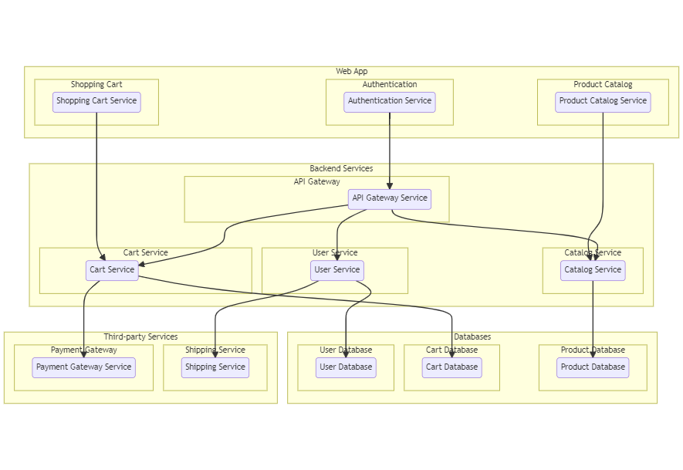

The technical architecture of an flower and gift delivery app typically involves a client-server model, where the frontend represents the client and the backend serves as the server. The frontend is responsible for user interface, interaction, and presentation, while the backend handles data storage, business logic, and integration with external services like payment gateways and databases. Communication between the frontend and backend is typically facilitated through APIs, enabling seamless data exchange and functionality.

**ER Diagram:**

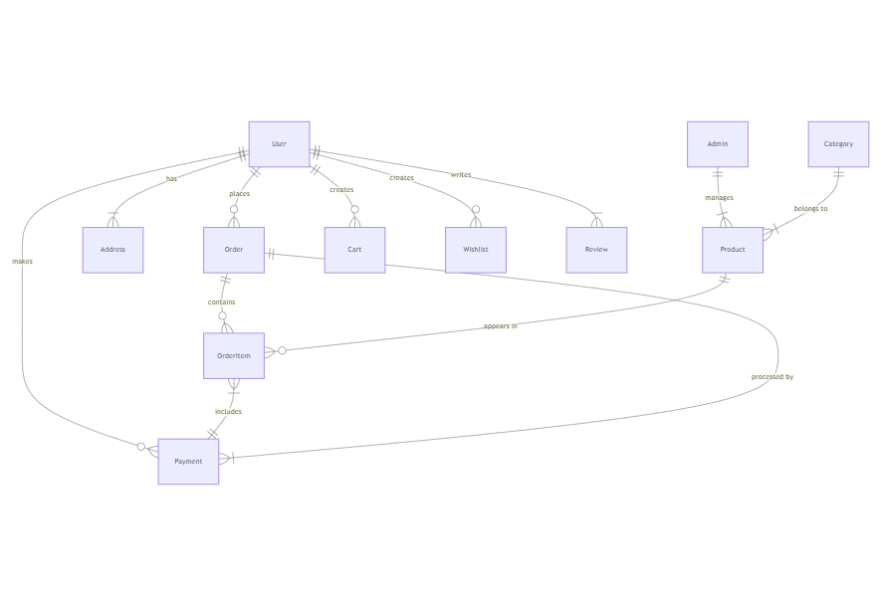

The Entity-Relationship (ER) diagram for an flower and gift delivery app visually represents the relationships between different entities involved in the system, such as users, products, orders, and reviews. It illustrates how these entities are related to each other and helps in understanding the overall database structure and data flow within the application.